**Project 3 Proposal**

**Skin Diagnosis Application**

**Section 1: GOAL STATEMENT**

Skin diseases are one of the most common diseases in human and its incidence is increasing drastically. If skin diseases are not treated in early stage them it may lead to complication. It may spread or transmit from one person to another.

In today's world, diagnosis consists of laboratory procedures, which consumes lot of time to detect the disease. On the other hand, computer-using algorithm can efficiently and effortlessly interpret lot of images. By the use computer vision, we are creating a skin disease diagnosis-using image. Where user can able to capture the image anywhere anytime by anyone. When user captures the image using this app, it processes the image and shows the result accordingly.

**Section 1.1** **INPUT**

Input of the application will be skin image which show the disease part visible.

Example:

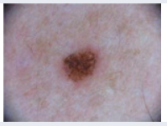

Input image will be captured with good quality and need to upload in system. The captured image should be taken from a short range and not more than 8 inch for better result.

**Section 1.2 OUTPUT**

Output will be skin disease name with risk level based on training data & dataset.

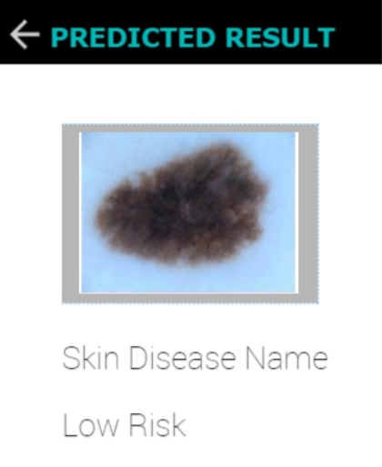

**Section 2: DEVELOPMENT PLATFORM AND TARGET AVD AND DEVICE**

We are targeting SDK Version 29, with minimum SDK Version 23. Our Android Application that can identify skin disease using deep learning through Convolutional Neural Network (CNN).

We will be testing on Samsung S20.

**Section 3: ALGORITHM** - CNN 3-layered Model

<https://github.com/standard-deviant/skin-cancer-classification>

**Section 3.1: OVERVIEW**

In our proposed system following are the major component:

1. Preprocessing
2. CNN model
3. Model Evaluation

**Section 3.2: EXPLANATION**

1. **Data Preparation** – Multiple set of images of same person are acquired where most of the dataset contains the sets of images in jpeg extension. This extension is related to the same skin lesion. After got prepared with the dataset, we need to pre-process each of the images using these steps:

**a) Visual Inspection** – In order to eliminate the non-representative images or which or of poor quality.

**b) Image Resizing** – Transform images to specific required size. Here we resize them to 128x128x3.

**c) Crop and other Imaging smoothening process** – we perform these to make the image more suited for feature extraction.

1. **CNN Model:**

Convolutional 3-Layer:

**Layer1** – The resized image is given as an input to this layer. It undergoes element-wise multiplication and then summed up to form a feature map.

**Layer2** – The activation map from previous step added with some filters is used as an input to get the output as activation which represents the features in higher-level.

**Layer3** – The higher-level features from previous layers are further processed to obtain a fully- connected layer by applying softmax classification technique.

**Training Algorithm** – To fit the model the following parameters are used to fit the model the learning rate is 0.0001, the activation is softmax, the loss is categorical cross entropy, the optimizer is Adam and the epoch is 30.

1. **Model Evaluation**: ROC curves and AUC Score are used to evaluate the model. Firstly we check the tradeoff between TPR and FPR, accordingly we choose the model which fits it to achieve greater precision or accuracy.

**Section 3.4: RESULT**

We will be using standard database for the development and testing of proposed system. Thus, by using ensemble features as well as deep learning, predictions can be achieved with a higher rate than previous models. It is also found that Convolution Neural Networks (CNN) performs well as compared to other Neural Networks in the diagnosis of skin diseases. The better outcome achieved to predict and prevent the dermatological diseases using the techniques in CNN as model which was trained on using the imbalanced dataset and the default preprocessing of input data.

**Section 4: GUI Interface**

**Section 4.1 Home Interface**

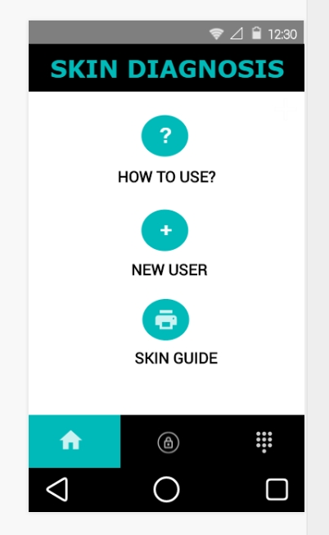

**Section 4.2 Login Interface**

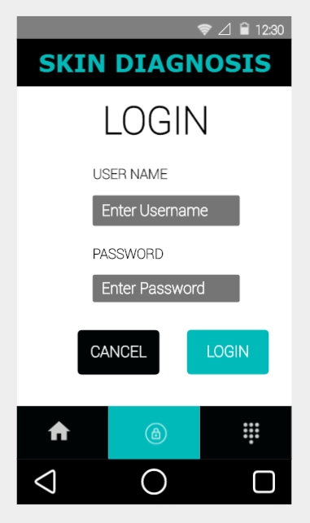

**Section 4.3 Input Interface**

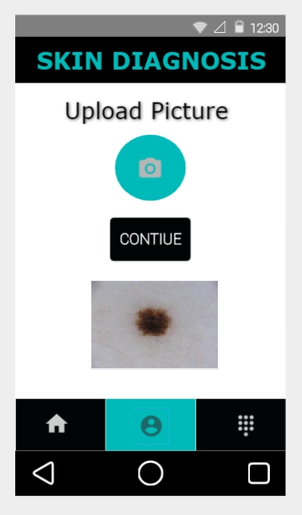

**Section 4.4 Output Interface**

